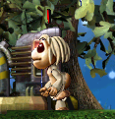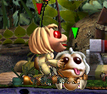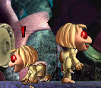Atavist Ettins
‘Atavism’ is the state of reverting to an earlier evolutionary form. These Ettins look like and behave similarly to the Ettins of Albia!

They have two life stages, and the sprites have been fixed to allow breeding with other varieties of Ettin (Standard C3 Ettin, Poodle Ettin, Plague Ettin, Yettin, Lemming Ettin, etc) without any of their appendages looking disproportionate or the dreaded flying head syndrome.

Included:
Unzip AtavistettinSprites.zip into ‘images’ folder of C3 (or DS if you don’t have C3)
Unzip AtavistettinAtts.zip into ‘body data’ folder of C3 (or DS if you don’t have C3)
Place the exported creatures, George and Nicola, in the creatures folder of C3 (or DS if you don’t have C3) and the agent in the agents folder. If you wish, you can put ettn-wild.gen into your genetics folder – this means the Ettin egg layer will lay some Atavist Ettin eggs along with the normal ones.

Now you can import George and Nicola into either C3 or DS. You’ll probably find them more at ease than normal Ettins; they aren’t interested in stealing the ship’s equipment, preferring as they do the garden, and they sleep a bit more and can get by on food alone. They do not live as long nor breed as prolifically as the C3 Ettins, and they are easier to cater for in DS only worlds.

http://tangentrine.com/content/wyvernslodge

